**INTERNET OF THINGS REPORT**

**GROUP 1**

Hồ Gia Mẫn

Lưu Hồng Đông My

Trần Thị Vân Khánh



**Topic 5:** Automatic hand sanitizer with alarm sound

**I. Introduction about this project.**

**Quickview about IOT and its benefits:**

According to Wikipedia, The Internet of things (IoT) describes physical objects (or groups of such objects) that are embedded with sensors, processing ability, software, and other technologies that connect and exchange data with other devices and systems over the Internet or other communications networks.

The internet of things helps people live and work smarter, as well as gain complete control over their lives. In addition to offering smart devices to automate homes, IoT is essential to business. IoT provides businesses with a real-time look into how their systems really work, delivering insights into everything from the performance of machines to supply chain and logistics operations.

IoT enables companies to automate processes and reduce labor costs. It also cuts down on waste and improves service delivery, making it less expensive to manufacture and deliver goods, as well as offering transparency into customer transactions.

## **Internet of Things Devices & Examples**

* ***Amazon Echo and Google Home - Smart Home:*** AI voice assistants like the Amazon Echo and Google Home are some of the most popular connected devices in consumer IoT. Users can talk to voice assistants like Alexa for help performing a variety of functions including playing music, providing a weather report, getting sports scores, ordering an Uber, and more.

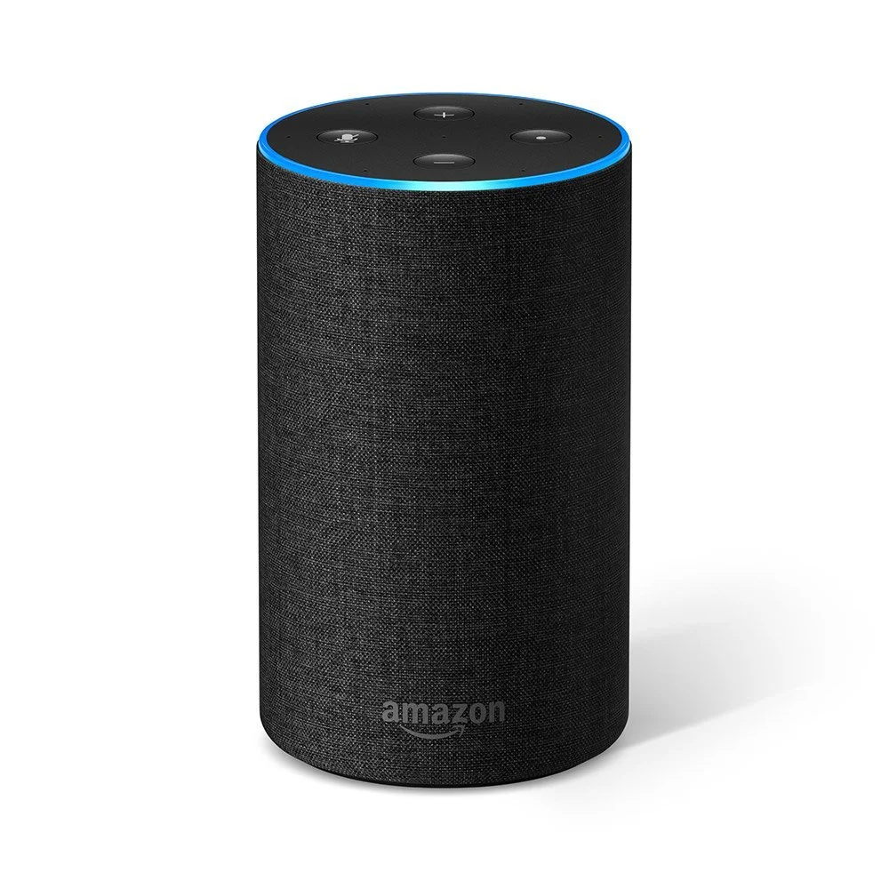

* ***Apple Watch:*** The Apple Watch tracks your steps, floors climbed, calories burned, and sleep quality. The device also syncs with computers and smartphones through wifi to transmit your fitness data in understandable charts to monitor your progress.

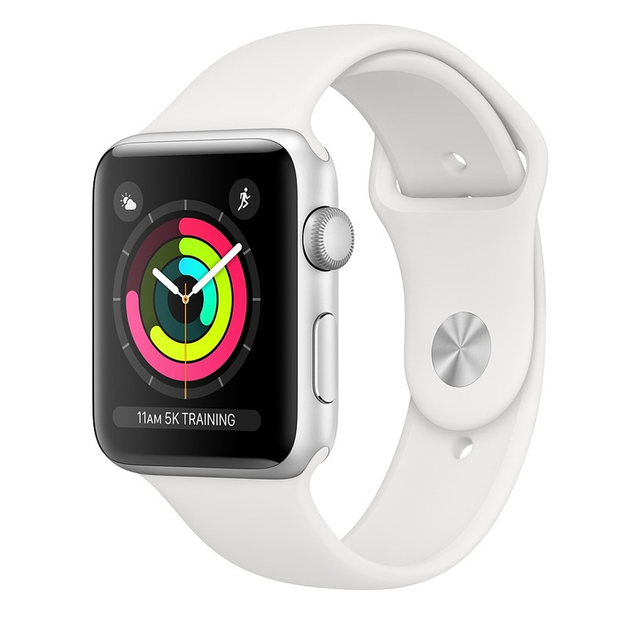

* ***AT&T - Connected Car:*** AT&T was the first telecom company to open a connected car research and innovation center.



**Project Synopsis**

It has been two years since the outbreak of COVID-19. It is a [contagious disease](https://en.wikipedia.org/wiki/Contagious_disease) caused by severe acute respiratory syndrome coronavirus 2 (SARS-CoV-2). The first known case was identified in [Wuhan](https://en.wikipedia.org/wiki/Wuhan), China, in December 2019. The disease has since spread worldwide, leading to [an ongoing pandemic](https://en.wikipedia.org/wiki/COVID-19_pandemic).

One of the ways to protect yourself from this disease is to wash your hands with soap or hand sanitizer. The World Health Organization (WHO) also recommends that individuals wash hands often with soap and water for at least twenty seconds, especially after going to the toilet or when hands are visibly dirty, before eating and after blowing one's nose. Hence, this project was born. We want to build an automatic hand sanitizer with an alarm sound system to help people wash their hands more. The product will be mostly used in classrooms and/or work offices.

**Objectives and Vision**

Our group was formed for the IOT102 (Introduction to Internet of Things) course. There are a total of three members. With the guidance of Mr. Loi, we have utilized our knowledge and resources to create this product. This is only for educational purposes.

Our objective is to draw more people’s attention to the significance of washing their hands and make it convenient for them to do so with our automatic hand sanitizer. We hope that this project can help fight the pandemic battle and increasingly raise people’s immunity to the deadly virus. With that, we seek to contribute our force to finally end this long-lasting and dangerous disease along with more awareness of the hygiene matter.

**II. About hardware**

**Components**

1. Arduino Uno R3

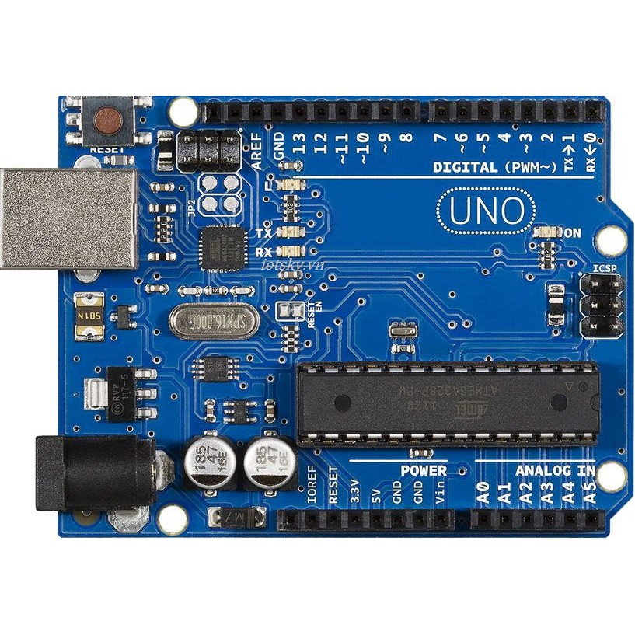

1. 4R 3W speaker

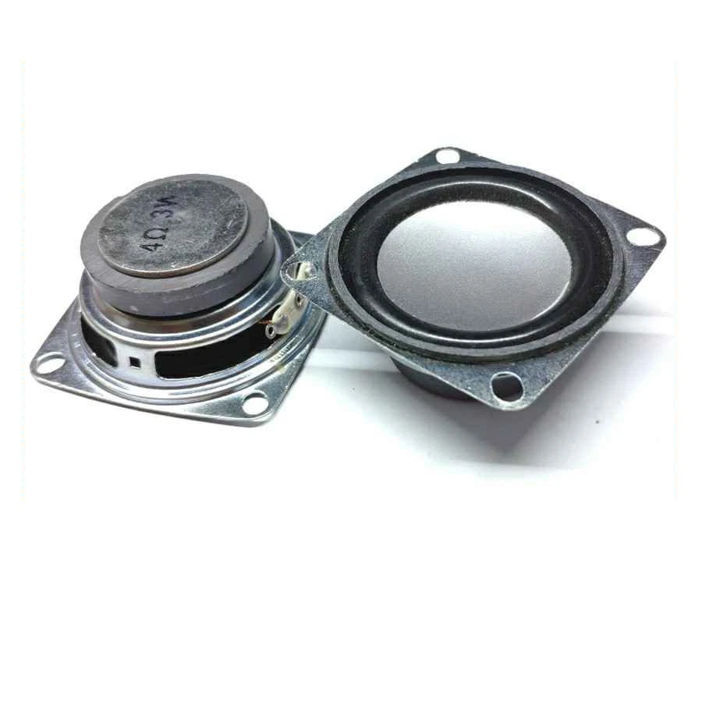

1. Ultrasonic sensor US-016

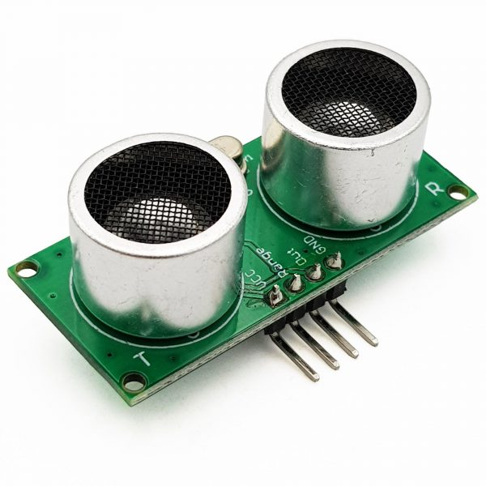

1. Servo motor MG996R

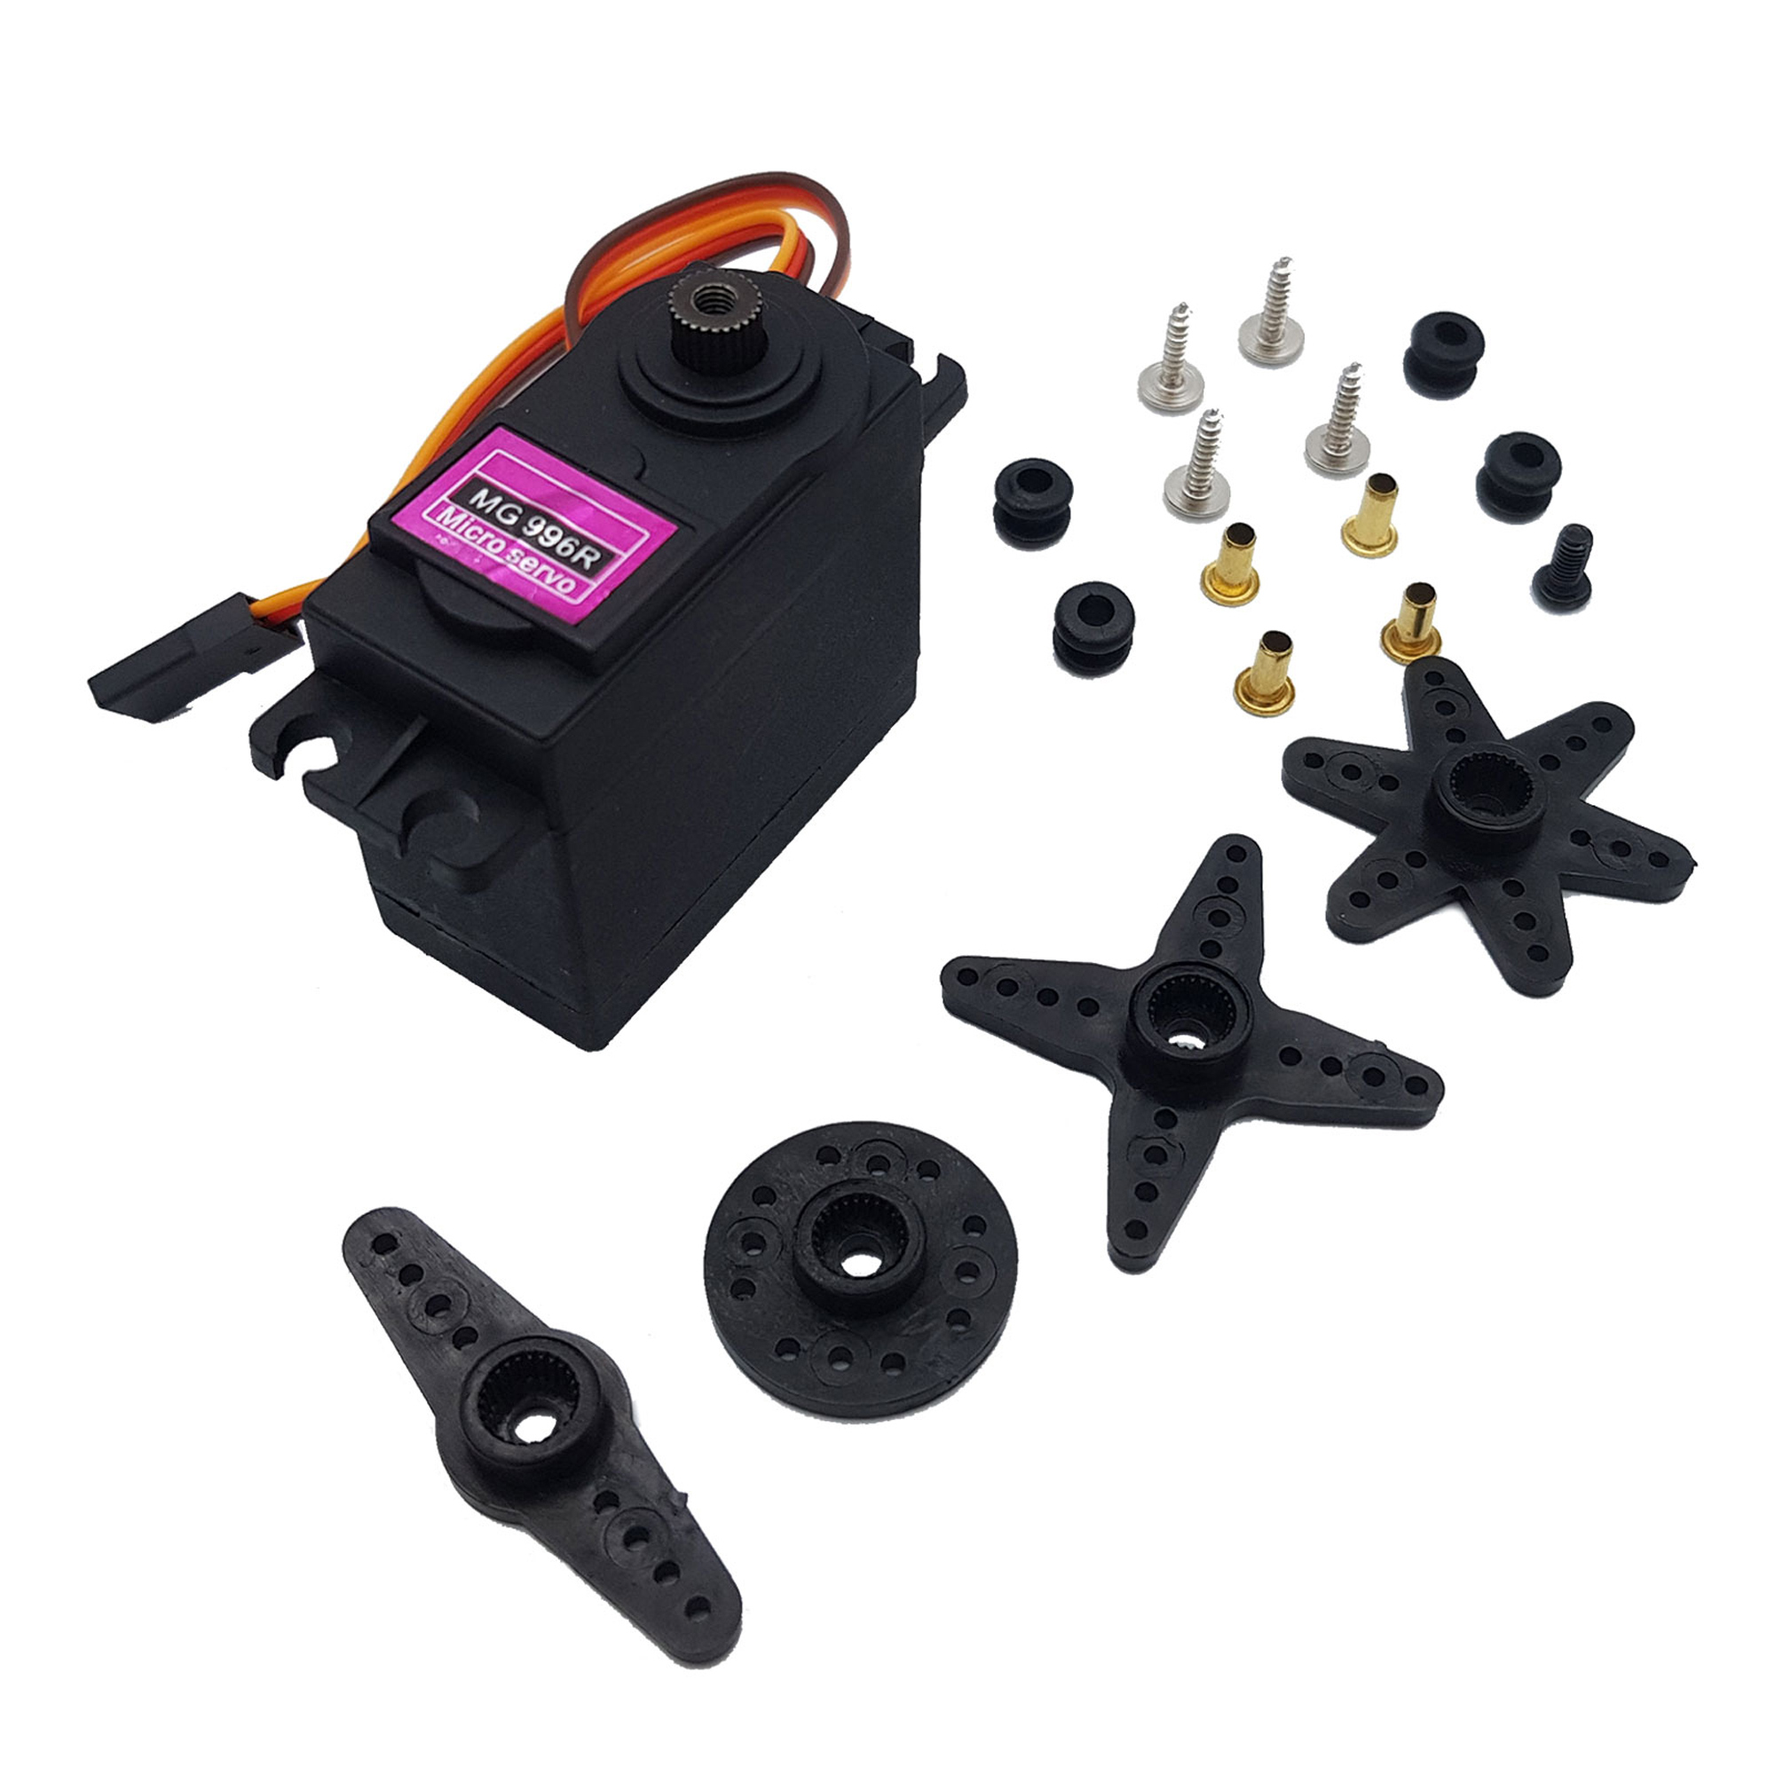

1. Mini breadboard

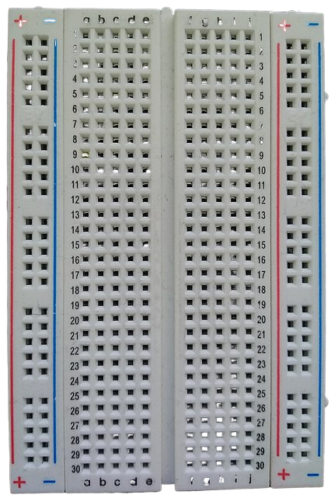

1. Micro-SD card

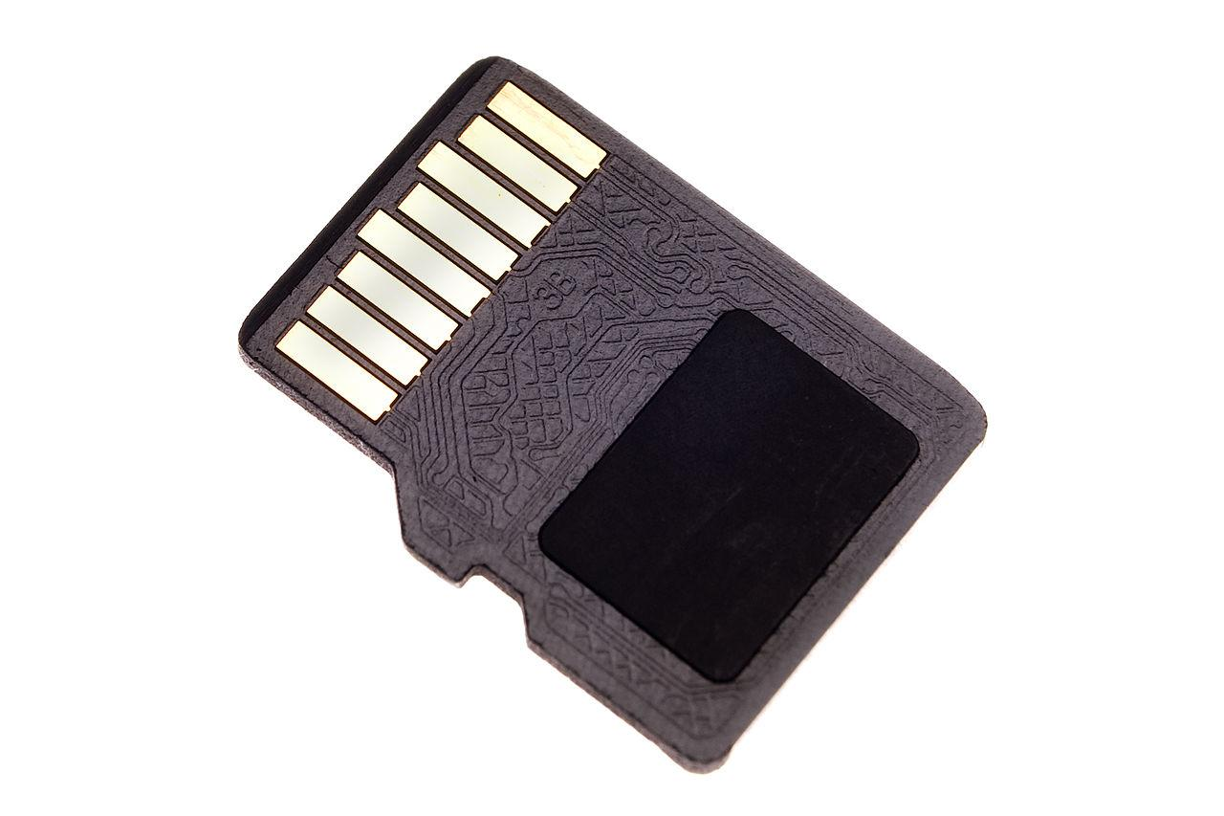

1. Sanitizer bottle

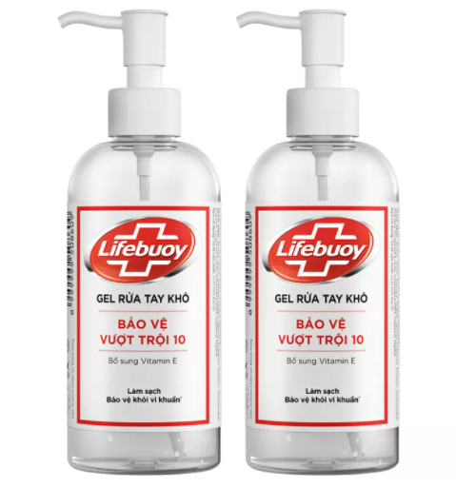

1. Jumper wire

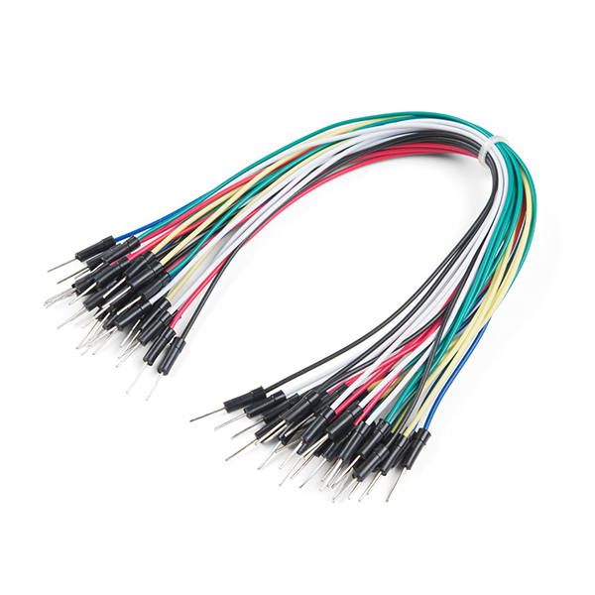

1. DFPlayer Mini MP3 Player

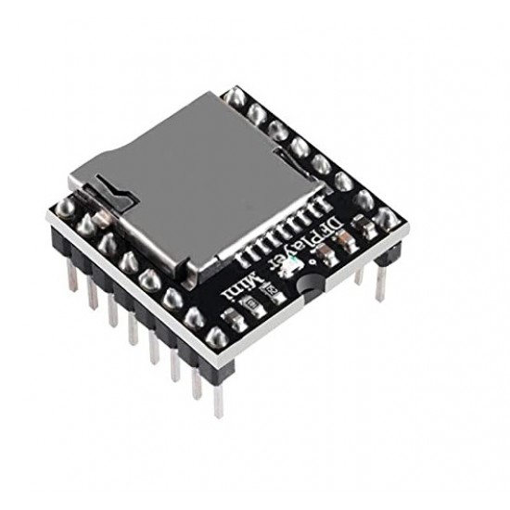

**Properties of components**

* Arduino Uno R3: a microcontroller board onto which programs can be easily loaded from the Arduino computer program.
* 4R 3W Speaker: an audio speaker which is small enough to put in the automatic hand sanitizer.
* Ultrasonic sensor US-106: an highly-effective sensor provides detection of non-contact measurement functionality with a ranging accuracy that can reach up to 3 meters.
* Servo motor MG996R: a high-speed standard servo motor can rotate 180 degrees (90 in each direction).
* Mini breadboard: a board which you can use to join parts together without having to solder them together.
* Micro-SD card: used to store and transfer files at high speed.
* Jumper wire: used together with the breadboard to connect the components.
* Sanitizer bottle: a bottle of 235 ml in volume that provides dry hand cleansing gel.
* DFPlayer Mini MP3 Player: The [DFPlayer Mini MP3 Player For Arduino](https://www.dfrobot.com/product-1121.html) is a small and low price MP3 module with a simplified output directly to the speaker. The module can be used as a stand alone module with attached battery, speaker and push buttons or used in combination with an [Arduino UNO](https://www.dfrobot.com/product-610.html) or any other with RX/TX capabilities.

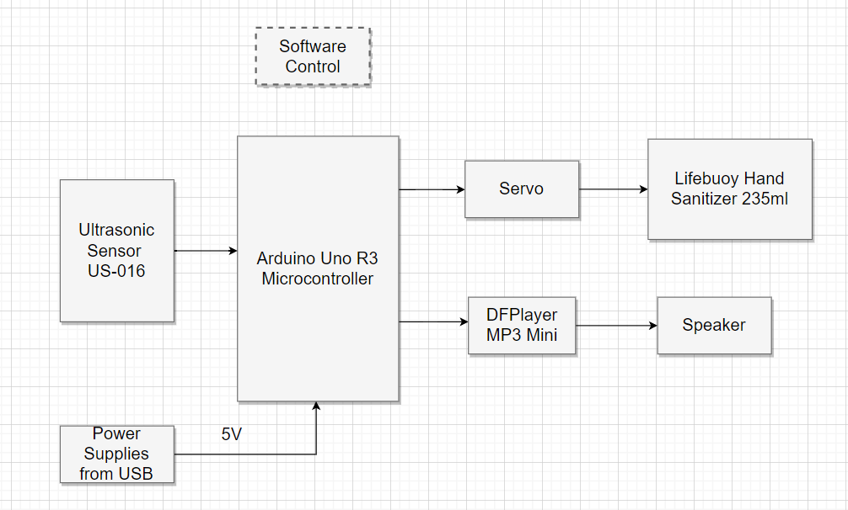

**Schematic design**

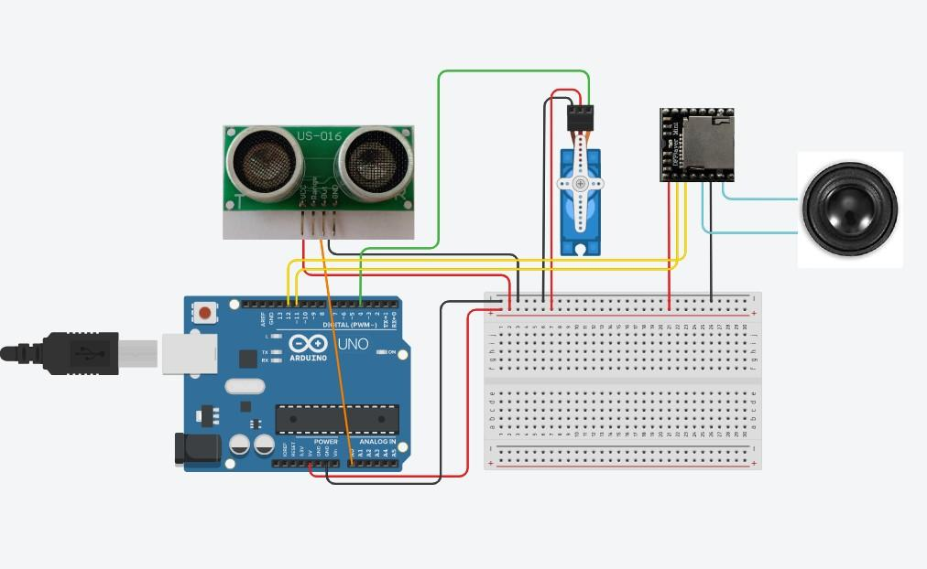

**III. About software**

**Requirement analysis**

1. Functional requirement:

|  |  |
| --- | --- |
| **Features** | **Requirements** |
| Dispense sanitizer | The product must automatically dispense sanitizer when a person reaches out their hand. |
| Play audio | - The product must remind a person when they pass by without washing their hands.  - The product must thank them after their hand washing. |
| Sense | The product must be able to detect when a person comes close. |
| Motor rotation | The servo motor has to rotate a specific angle to sufficiently pull the bottle lid down. |

1. Non-functional requirement:

| **Availability** | The product must work at any time, given that there is still substance left in the bottle. |
| --- | --- |
| **Usability** | The product must be user-friendly and effective. |
| **Reliability** | The product can accurately detect 99% of the time. |
| **Maintainability** | The bottle is changed once a week. |
| **Localization** | The hand sanitizer is mostly used in classrooms and/or offices. |
| **Compatibility** | The hand sanitizer used is Lifebuoy Antibacterial Hand Sanitizer. Its volume is about 235 milliliters. The product has over 60% alcohol content and gives instant germ protection. |

**Flowchart**

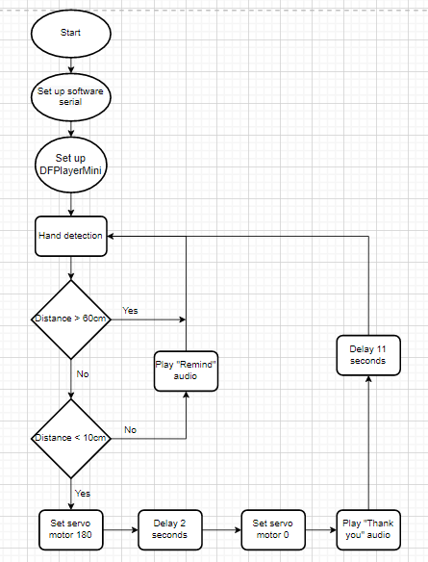

**Source code**

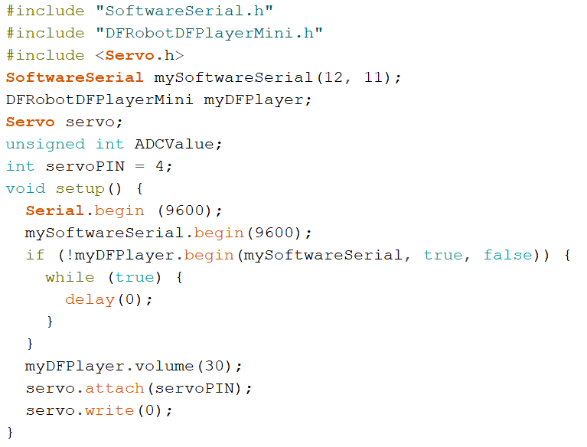

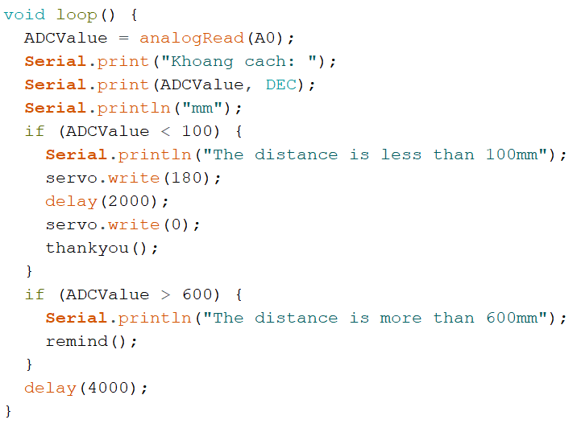

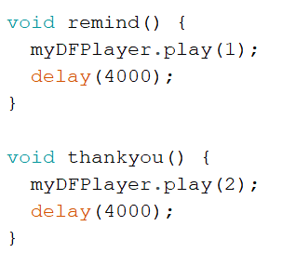

**IV. Implementation and inspection**

**Implementation**

We have recorded our process of the product making. Outsiders can access the video with the link given below.

<https://drive.google.com/file/d/1g17564UuBPNaSSNWDvlFmnJrAmP1Z6A0/view?usp=sharing>

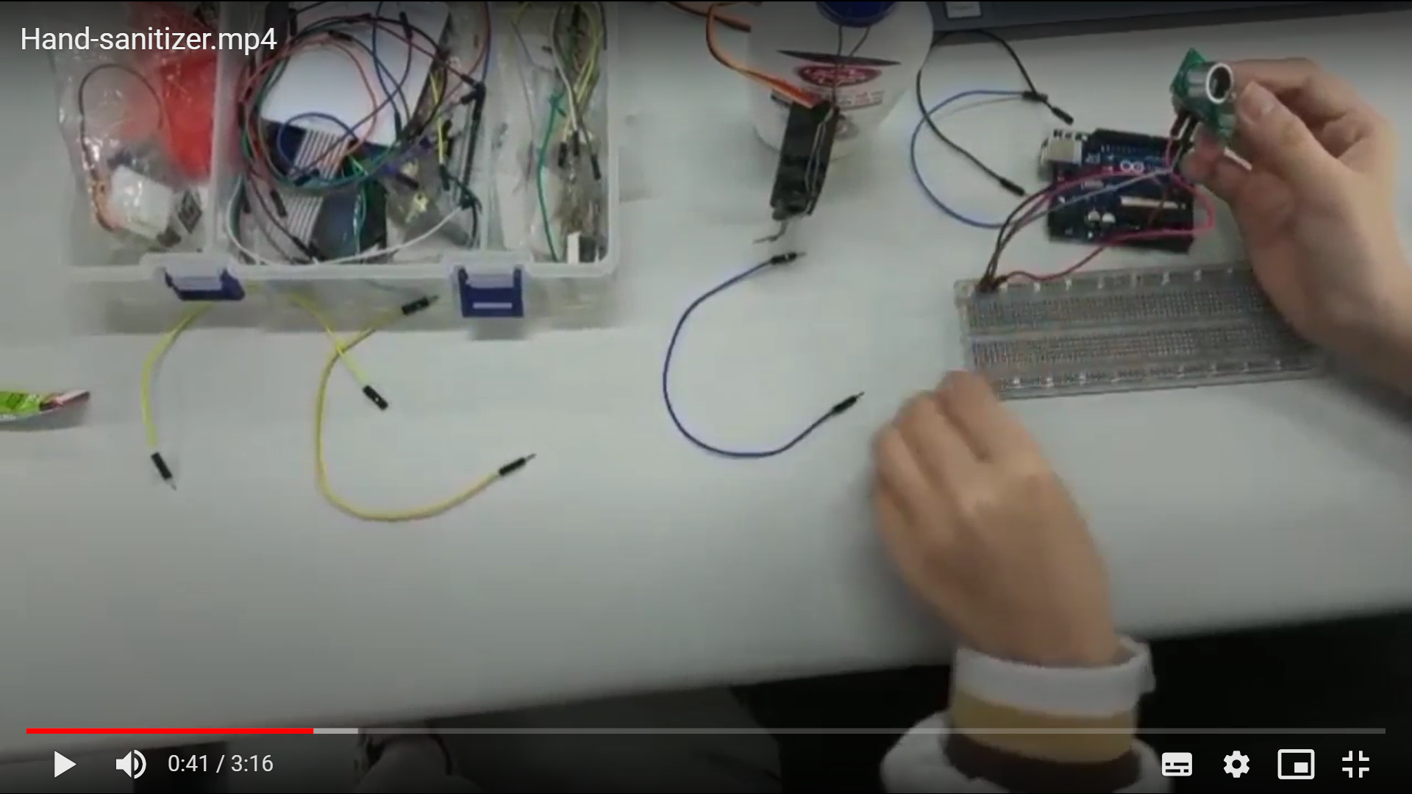

**Cost Analysis/Budget:**

Since FPT university’s library is mostly out of Arduino kit for learning, although we have managed to borrow one, it still lacked some of the most significant accessories. Therefore, we have bought some of the components ourselves as listed below:

|  |  |  |
| --- | --- | --- |
| **Components** | **Cost** | **Note** |
| Ultrasonic Sensor US-106 | 70000 VND |  |
| Servo MG996R 180deg | 90000 VND |  |
| Micro SD Card Module | 19000 VND |  |
| 4R 3W Speaker | 22000 VND |  |
| DFPlayer Mini MP3 Player | 52000 VND |  |
| Jumper wire | 10000 VND |  |
| Total | 263000 VND | |

**Upon inspection/Testing**

When we first got the ultrasonic sensor HC-SR04 to run, we approached a problem where the sensor did not work as intended. The distance returned was always 0. Turned out, the sensor was flawed so we bought a newer and costlier one. (US-016)

When connected to the power source of a laptop, the whole Aruino board worked well as expected as the ultrasonic sensor detected the right distance of several objects and obstacles. The servo motor turned exactly 180 degrees. The speaker, transmitted and amplified through a player, was very loud and clear. The servo was hard to attach to the sanitizer bottle since we only used ropes and tapes. Nonetheless, we resolved the matter with a super glue. The hand sanitizer discharged a lot of substance. We consider this a success.

**V. Conclusion**

This project has inspired our group members to be more creative and get more hands-on experience with hardware engineering. It also carries meaning and practicality for real life problems and situations, especially in this Coronavirus pandemic where us humans have to deal with a threatening airborne disease. A hand sanitizer will not only help a great deal to progressively stop the spread of the variants amongst people but also remove dirt and germs from your hands that can cause E. coli, diarrhea, and other respiratory infections like adenovirus. Our group is grateful for the course’s learning material and desires to create more serviceable and helpful products like this in the future.

**References:**

Arduino hand sanitizer: [https://www.youtube.com/watch?v=sxqBbkhozYM](https://www.youtube.com/watch?v=sxqBbkhozYM&list=LL&index=4&t=167s)

Operate on DFMini MP3 Player: <https://www.youtube.com/watch?v=Ybe9LJMdyVo>

Internet of Things: <https://en.wikipedia.org/wiki/Internet_of_things>

Components: <https://www.arduino.cc/>